
School of Computer Science and Engineering
Department of Computer Science & Engineering (Artificial Intelligence)
Faculty of Engineering & Technology
Jain Global Campus, Kanakapura Taluk - 562112
Ramanagara District, Karnataka, India

2022-2026
(IV Semester)

A PCL Project Report on

“AIRTOUCH”

Bachelor of Technology
in
COMPUTER SCIENCE AND ENGINEERING
(Artificial Intelligence)

Submitted by

Jery, Ayushmaan, Pavan, Ranveer, Yashwanth
22BTRCA061, 22BTRCA004, 22BTRCA020,22BTRDC045,22BTRCA013

Under the guidance of

Dr. N Sateesh
Professor
Department of Computer Science and Engineering (Artificial Intelligence)
School of Computer Science & Engineering
Faculty of Engineering & Technology
JAIN (Deemed to-be University)
2023-2024
<

DECLARATION
We, Jery (22BTRCA061), Ayushmaan (22BTRCA004), Pavan (22BTRCA020), Ranveer (22BTRDC045), Yashwanth (22BTRCA013) student of 4th semester B. Tech in Computer Science and Engineering (Artificial Intelligence), at School of Computer Science & Engineering, Faculty of Engineering & Technology, JAIN (Deemed to-be University), hereby declare that the internship work titled “AirTouch” has been carried out by us and submitted in partial fulfilment for the award of degree in Bachelor of Technology in Computer Science and Engineering(Artificial Intelligence) during the academic year 2023--2024. Further, the matter presented in the work has not been submitted previously by anybody for the award of any degree or any diploma to any other University, to the best of our knowledge and faith.
Dr. N. Satheesh
Professor
Dept. of CSE - AI

Name1: Jery
USN : 22BTRCA061
Signature

Name2: Ayushmaan D.J Neog
USN : 22BTRCA004
Signature

Name3: Pavan Karthikeya
USN : 22BTRCA020
Signature

Name4: Ranveer Kakati
USN: 22BTRDC045
Signature

Name5: Yashwantha Rayalu G V
USN: 22BTRCA013
Signature

Place : Bangalore
Date :

TABLE OF CONTENTS

Declaration ii
List of figures v
List of tables v
Nomenclature used v

Chapter 1 1
Introduction 1
1.1 Background & Motivation 1
1.2 Objective 1
1.3 Delimitation of Research 1
1.4 Benefits of Research 2
Chapter 2 3
LITERATURE SURVEY 3
2.1 Literature Review 3
2.2 Inferences Drawn from Literature Review 4
Chapter 3 6
Problem Formulation and Proposed Work 6
3.1 Problem Statement 6
3.2 Existing System 7
3.3 System Architecture /Model 7
3.4 Proposed Algorithms 8
3.5 Proposed Work 10
Chapter 4 12
Implementation 12
4.1 Software Requirements 12
4.2 Hardware Requirements 14
Chapter 5 16
Software Architecture 16
5.1 Software’s Architecture 16
5.2 Use Case Diagram 16
5.3 Flow Diagram 17

References 19

LIST OF FIGURES
Fig. No. | Description of the figure | Page No.
Fig 4.2 | Use Case Diagram | 14
Fig 4.3 | Flow Diagram | 15
Fig 5.1 | Software Architecture | 16

LIST OF TABLES
Table No. | Description of the Table | Page No.
Table 2.1 | Literature Review | 3
Table 2.2 | Different Range Sensors and their Characteristics | 6
Table 3.4 | Comparative Analysis of Algorithms | 9

NOMENCLATURE USED
TOF | Time Of Flight
ML | Machine Learning

Chapter 1

Introduction

1.1 Background & Motivation
The concept of AirTouch emerges from a profound desire to revolutionize the way we interact with technology. As our reliance on digital devices grows, so does the need for interfaces that are not only intuitive but also seamless and adaptable to various environments. Traditional touchscreens have limitations, primarily tied to physical surfaces and their fixed functionalities.

The background of the AirTouch project lies in the quest to transcend these limitations. Its genesis can be traced to the convergence of advancements in sensor technology, particularly Time-of-Flight (TOF) sensors, and the growing demand for touchless interfaces. By leveraging TOF sensors, AirTouch pioneers a paradigm shift in human-computer interaction, allowing any surface to be transformed into a touchscreen.

Motivated by the vision of a touchless future, AirTouch aims to democratize access to interactive technology. Whether it's in public spaces, homes, or workplaces, AirTouch envisions a world where any surface can become a canvas for creativity, productivity, and connectivity. By eliminating the need for physical touch, AirTouch not only enhances hygiene and safety but also opens up possibilities for new forms of interaction, particularly in contexts where touchscreens are impractical or inaccessible.

1.2 Objective

Surface-less interaction:
To eliminate the need for physical contact with touch screens or buttons. This provides a more hygienic and intuitive user experience, especially in shared environments along side the added advantage of reduced maintenance costs.

Improved User Experience:
To offer a more intuitive and natural way to interact with devices. With AirTouch, users can interact with devices in a way that feels more natural, like reaching out to touch an object in mid-air.

Versatility:
To innovate a technology that is versatile and can be used in a variety of settings and applications, from education to home automation and automotive industries.

1.3 Delimitation of Research
The delimitations of research in the context of AirTouch, or any similar project, help to define the scope and boundaries within which the study operates. Here are some potential delimitations:

- Technical Constraints: Research may be delimited by technical limitations such as the accuracy and range of the Time-of-Flight (TOF) sensors used in AirTouch technology. The effectiveness of the system may be limited by factors such as sensor resolution, processing power, or environmental conditions.
- Surface Compatibility: The research may focus on specific types of surfaces or materials that are compatible with AirTouch technology. Certain surfaces may be more conducive to accurate touch detection than others, and the study may delimit the evaluation to these surfaces.
- User Interaction: The study may delimit the analysis to certain types of user interactions or gestures supported by AirTouch technology. Complex gestures or interactions may be excluded from the scope of the research due to feasibility or practicality considerations.
- Application Focus: The research may be delimited to specific applications or use cases of AirTouch technology. For example, the study may focus on AirTouch's implementation in retail environments or healthcare settings, excluding other potential applications.

1.4 Benefits of Research
Through AirTouch, the conclusive research offers numerous benefits across various domains. Here are some key advantages:

- Innovation and Advancement: Research drives innovation by pushing the boundaries of knowledge and technology. Through projects like AirTouch, researchers develop new concepts, methodologies, and solutions that can lead to significant advancements in human-computer interaction and related fields.
- Economic Growth and Competitiveness: Research stimulates economic growth by fostering innovation, entrepreneurship, and the development of new products and services. Technologies like AirTouch have the potential to create new markets, generate revenue, and contribute to the competitiveness of industries involved in human-computer interaction and related sectors.
- Social Impact and Well-being: Research can have a profound impact on society by addressing societal challenges, improving quality of life, and promoting inclusivity and accessibility. Projects like AirTouch that focus on touchless interaction can enhance hygiene, safety, and accessibility, particularly in public settings and for individuals with disabilities.
- Education and Training: Research offers opportunities for education and training, both for researchers themselves and for students and professionals in related fields. Projects like AirTouch provide practical learning experiences, promote interdisciplinary collaboration, and inspire the next generation of innovators and problem solvers.

Chapter 2

LITERATURE SURVEY

2.1 Literature Review
Table 1: Literature Review
S. No | Year of publish | Authors | Title of the paper | Published journal name | Problem addressed | Solution identified for problem
1 | 2023 | Gagana h ET AL | Innovation OF touchless touchscreen technology IN automotive user interface | Journal OF data mining AND management | Sensitivity TO ENVIRONMENTAL CONDITIONS | Ambient LIGHT FILTERING  Anti-REFLECTIVE COATINGS
2 | 2023 | Kazuma yoshino ET AL | Contactless touch interface supporting blind touch interaction BY aerial tactile stimulation | Graduate school OF information science AND technology | Limited SENSING RANGE | Optimize SENSOR PLACEMENT  Sensor AMPLIFICATION TECHNIQUES
3 | 1989 | Mary e. Dominessy | A LITERATURE REVIEW AND ASSESSMENT OF TOUCH INTERACTIVE DEVICES | U. S. Army human engineering laboratory | Sensitivity TO ENVIRONMENTAL CONDITIONS | Ambient LIGHT FILTERING  Anti-REFLECTIVE COATINGS
4 | 2019 | Kalaiselvi n ET AL | Touch less touch screen | International journal OF recent scientific research | Sensitivity TO ENVIRONMENTAL CONDITIONS | Ambient LIGHT FILTERING  Anti-REFLECTIVE COATINGS
5 | 2022 | Deepak pandav | Haptic technology | Irjmets | Limited PRECISION | Improve SENSOR RESOLUTION  Advanced SIGNAL PROCESSING ALGORITHMS
6 | 2011 | Daniel r. Schlegel ET AL | Airtouch: interacting with computer systems at a distance | Dblp | Limited GESTURE RECOGNITION | Integration OF MACHINE LEARNING ALGORITHMS  Multiple SENSOR CONFIGURATIONS
7 | 2017 | Naveen kumarasinghe | Airtouch - intelligent virtual multi-TOUCH screen | Sri lanka institute OF information technology | Limited GESTURE RECOGNITION | Integration OF MACHINE LEARNING ALGORITHMS  Multiple SENSOR CONFIGURATIONS
8 | 2019 | Dong-SEOK lee | Virtual touch sensor USING A DEPTH CAMERA | Advanced technology FOR smart home automation AND entertainment | Sensitivity TO ENVIRONMENTAL CONDITIONS | Ambient LIGHT FILTERING  Anti-REFLECTIVE COATINGS
9 | 2023 | Ali Shtarbanov et al | Soft Robotics and Programmable Materials for Human-Computer Interaction | 2023 ACM Designing Interactive Systems Conferance | Challenges in Fabrication methods, durability tools, access to resource, and transfer of knowledge | Soft Robotics design and fabricaton and concepts of future applicatoons for their integration into daily life
10 | 2020 | Carlos E. Tejada | Airtouch: 3D-printed Touch-Sensitive Objects using Pneumatic Sensing | 2020 CHI Conference on Human factors in Computing systems | Difficulty in Assembling components for 3D printing technology | Use pre-trained machine learning models to fabricate touch-sensitive objects and calibrate using pneumatic sensing
11 | 2023 | Hojung Choi et al | Integrated Pneumatic Sensing and Actuation for Haptic Devices | IEEE | Difficulty in providing consistent haptic feedback among different users | Intergrated pneumatic sensor and actuators for soft haptic devices
12 | 2023 | Tianyu Yuet al | Thermotion: Design and Fabrication of Thermofluidic Composites for Animation Effects on Objects Surfaces | 2023 CHI Conference | Inconsistent temperature Variation | Composites utiliize thermofluidic flows using fluidic channels to dynamically control the surface temperature

2.2 Inferences Drawn from Literature Review

Sensitivity to Environmental Conditions:
Many papers address the challenge of touchless interfaces being sensitive to environmental conditions such as ambient light, which can affect their performance. Solutions proposed include ambient light filtering and anti-reflective coatings to mitigate these issues.

Limited Sensing Range and Precision:
Some research focuses on overcoming limitations in sensing range and precision, particularly in contactless touch interfaces. Strategies include optimizing sensor placement, amplification techniques, improving sensor resolution, and employing advanced signal processing algorithms.

Gesture Recognition and Interaction:
Limited gesture recognition capabilities have been identified as a challenge. Solutions involve integrating machine learning algorithms and employing multiple sensor configurations to enhance gesture recognition and interaction with computer systems.

Soft Robotics and Programmable Materials:
Recent work explores the integration of soft robotics and programmable materials for human-computer interaction. Challenges include fabrication methods, durability, resource access, and knowledge transfer. Solutions involve designing and fabricating soft robotics with future applications in daily life.

Innovative Sensing Technologies:
Papers introduce innovative sensing technologies such as virtual touch sensors using depth cameras, pneumatic sensing, and actuation for haptic devices, and thermofluidic composites for animation effects. These technologies aim to enhance touchless interaction and provide consistent haptic feedback.

Conference and Journal Contributions:
The literature review spans various conferences and journals, indicating a diverse range of research sources and collaborations in the field of touchless touchscreen technology and human-computer interaction.

In summary, the literature review highlights ongoing efforts to address challenges and innovate in touchless touchscreen technology, focusing on improving environmental robustness, sensing capabilities, gesture recognition, and exploring novel materials and sensing techniques for enhanced user interaction.

Table 2: Comparison of different sensors
S. No | Method | Characteristics
 |  | Power Usage |  | Range | Accuracy | Latency | Cost
1 | Using Ultrasonic | 2~20 mA | 0.2~5 m |  | ~35 mm/cm | 20~100 ms | ₹150 - ₹2,200
2 | Using Lasers | 50~500 mA | 0.1~100 m |  | ~20 mm/cm | 0.1~1 ms | ₹1,100 - ₹70,000+
3 | Using TOF Sensors | 20~200 mA | 0.1~10 m |  | ~1 mm/cm | 1~5 ms | ₹700 - ₹10,500+
4 | Using Infrared | 10~50 mA | 0.1~5 m |  | ~8 mm/cm | 1~10 ms | ₹350 - ₹3,500

Chapter 3

Problem Formulation and Proposed Work

3.1 Problem Statement
The problem statement for the described touchless interface technology using TOF range sensors, known as AirTouch, revolves around enhancing user experience through intuitive and hygienic interactions without physical touch. This innovative technology aims to eliminate the need for physical screens by detecting finger touch gestures in mid-air and translating them into click events for connected devices. The primary challenge addressed by AirTouch is to provide a seamless and user-friendly interface that offers a touchless experience, promoting convenience, cleanliness, and accessibility across different fields and applications. By leveraging TOF range sensors and advanced gesture recognition capabilities, AirTouch seeks to redefine human-computer interaction, paving the way for a future where touchless interfaces become the norm, transforming how users engage with technology in diverse environments.

AirTouch aims to address this challenge by utilizing Time-of-Flight (TOF) range sensors to detect finger touch gestures in mid-air and translate them into click events for connected devices. However, developing such a technology requires overcoming several technical and practical hurdles. These include:

Accuracy and Reliability:
Ensuring precise detection of finger touch gestures in mid-air without any false positives or missed inputs is essential for a seamless user experience.

Integration with Existing Devices:
AirTouch must be compatible with a wide range of electronic devices, including smartphones, tablets, computers, and interactive displays, without requiring significant modifications to the existing hardware or software.

Hygiene and User Experience:
The touchless interface should not only provide a hygienic alternative to traditional touchscreens but also offer an intuitive and user-friendly experience that users find comfortable and easy to adopt.

Scalability and Cost-effectiveness:
The technology should be scalable for mass production and deployment across various industries while remaining cost-effective to manufacture and maintain.

Environmental Factors:
External environmental factors such as ambient light, temperature, and humidity may affect the performance of TOF sensors, requiring robust algorithms and calibration techniques to ensure consistent operation in diverse conditions.

Security and Privacy:
As with any interface technology, ensuring the security and privacy of user data and interactions is paramount, requiring robust encryption and authentication mechanisms.

Addressing these challenges will be crucial for the successful development and adoption of AirTouch as a touchless interface technology with broad applications across industries such as healthcare, retail, transportation, and public infrastructure.

3.2 Existing System
The existing system of AirTouch, a touchless interface technology utilizing TOF range sensors, is designed to provide an intuitive and hygienic user experience. It relies on TOF range sensors to detect finger touch gestures in mid-air accurately, measuring the time taken for a light signal to travel to an object and back. This technology enables touchless interaction, where finger touch in mid-air is translated into click events that are sent to a connected device, eliminating the need for physical screens. In some applications, TOF sensors are used to create touchless interactive displays that project virtual screens or interfaces in the air using lasers or other projection technologies. The system is capable of distinguishing between user hovering and touching, as well as recognizing air touch and air tap gestures to identify the user's intent accurately. With its broad applications across various fields, including medical, industrial, and public spaces, AirTouch addresses the growing demand for hygienic and user-friendly interaction methods, especially in light of the Covid-19 pandemic.

3.3 System Architecture /Model
The system architecture or model for AirTouch, a touchless interface technology utilizing Time-of-Flight (TOF) range sensors, can be outlined as follows:

TOF Range Sensors:
The core component of AirTouch is the TOF range sensors. These sensors emit infrared light pulses and measure the time it takes for the light to reflect off objects in the environment and return to the sensor. This data is used to calculate the distance between the sensor and the object, enabling precise detection of finger touch gestures in mid-air.

Microcontroller/Processor:
The data collected from the TOF range sensors is processed by a microcontroller or processor unit. This unit interprets the distance measurements and identifies gestures made by the user's fingers in mid-air. It also manages the communication between the sensors and the connected device.

Communication Interface:
AirTouch communicates with the connected device, such as a smartphone, tablet, or computer, using a communication interface. This interface could be wired (e.g., USB) or wireless (e.g., Bluetooth, Wi-Fi), depending on the application and requirements.

Device Driver/Software:
On the connected device, a device driver or software component receives the touch input data from AirTouch and translates it into appropriate commands or actions. This software component may also include calibration algorithms to ensure accurate and reliable touch detection.

Integration with Projection Technology:
In some applications, AirTouch may be integrated with projection technology to create touchless interactive displays. This could involve projecting a virtual screen or interface in the air using lasers or other projection technologies, enhancing the user experience and enabling new interaction possibilities.

Overall, the system architecture of AirTouch consists of hardware components such as TOF range sensors and microcontrollers, communication interfaces, software components for touch detection and device interaction, and optional integration with projection technology, all working together to provide a touchless interface solution with various potential applications.

3.4 Proposed Algorithms
Table 3.4 Comparative Analysis of Algorithms
Algorithm/Technique | Principle/Methodology | Application | Advantages | Disadvantages
Phase-Shift Measurement | Measures phase shift between emitted and received signals using continuous wave modulation. | Distance measurement based on phase difference. | Accurate for precise distance calculations. | Susceptible to noise and interference.
Direct Time-of-Flight | Measures time taken for light pulse to travel directly to object and back. | Direct distance measurement. | Provides accurate distance readings. | Requires precise timing mechanisms.
Histogram-Based Algorithms | Collects multiple measurements to create a histogram of time intervals. | Improving accuracy and dealing with multiple reflections or noise. | Robust against noise and can handle complex environments. | Increased computational complexity.
Correlation Algorithms | Correlates received signal with a reference signal to determine time delay. | Used in phase-based ToF sensors. | Effective for phase-shift measurement in dynamic environments. | Can be computationally intensive.
Kalman Filtering | Applies Kalman filters to smooth out measurements and improve accuracy. | Dynamic environment with moving objects. | Provides real-time estimation and noise reduction. | Requires tuning of filter parameters.
Fourier Transform | Analyzes frequency components of modulated signals to determine phase shifts and distances. | Useful in phase-based systems. | Handles complex signals and noise effectively. | Processing overhead due to transformation.
Machine Learning Algorithms | Utilizes machine learning for object detection, classification, and improving distance measurements. | Enhancing accuracy and interpreting complex data patterns. | Adapts to varying environmental conditions. | Requires training data and computational resources.
Noise Reduction Techniques | Applies filters (e.g., median, Gaussian) to clean the signal and reduce noise. | Signal cleaning and enhancement. | Improves signal quality and accuracy. | May alter signal characteristics or introduce lag.
Multi-path Interference Handling | Algorithms designed to mitigate multi-path interference caused by reflections. | Dealing with complex environments. | Enhances accuracy in environments with reflective surfaces. | Requires sophisticated signal processing techniques.

- Precision in Distance Measurement:
  - For applications requiring precise distance measurement, Direct Time-of-Flight (ToF) is recommended. It directly measures the time taken for light to travel to the object and back, offering high accuracy in distance readings.
- Handling Dynamic Environments:
  - In environments with moving objects or changing conditions, Kalman Filtering is effective. It uses predictive models to smooth out measurements and reduce noise, providing reliable estimations in real-time.
- Noise and Interference Mitigation:
  - For environments with high noise levels or multiple reflections, consider Histogram-Based Algorithms and Noise Reduction Techniques (e.g., filters). These methods enhance accuracy by robustly handling noise and interference.
- Complex Signal Analysis and Pattern Recognition:
  - Applications requiring complex data analysis and pattern recognition benefit from Machine Learning Algorithms. These algorithms interpret intricate data patterns, making them suitable for tasks like object detection, classification, and improving distance measurements based on learned patterns.

3.5 Proposed Work

Prototyping and Hardware Development
- Sensor Selection and Integration: Select high-precision ToF sensors suitable for detecting finger gestures. Integrate these sensors into a compact and efficient hardware design.
- Microcontroller/Processor Integration: Choose an appropriate microcontroller or processor that can handle data processing and communication. Ensure the microcontroller can interface seamlessly with the ToF sensors and communication modules.
- Communication Interfaces: Develop wired (USB) and wireless (Bluetooth, Wi-Fi) communication modules. Ensure reliable and low-latency data transmission between the ToF sensor system and connected devices.

Software and Firmware Development
- Driver and Middleware Development:Develop device drivers to facilitate communication between the ToF sensors and the host device.Create middleware to process raw sensor data and translate it into meaningful gestures and commands.
- Gesture Recognition Algorithms:Implement and optimize algorithms for accurate gesture recognition.Develop software modules that can differentiate between various gestures such as taps, swipes, and hovers.

System Calibration and Testing
- Calibration:Develop calibration procedures to account for environmental factors like ambient light, temperature, and humidity.Implement automatic calibration routines to ensure consistent performance across different conditions.
- Testing and Validation:Conduct extensive lab and field testing to validate sensor performance and gesture recognition accuracy.Test the system in diverse environments and use cases to ensure robustness and reliability.

User Interface and Experience Design
- User Interface (UI) Design:Design intuitive user interfaces that complement the touchless interaction provided by the ToF sensors.Ensure that the UI provides clear feedback to users about detected gestures and system responses.

User Experience (UX) Testing:

- Conduct user testing to gather feedback on the ease of use and intuitiveness of the touchless interface.Iterate on the design based on user feedback to enhance overall user satisfaction.

Integration with Devices and Applications
- Compatibility:Ensure that the ToF sensor system is compatible with a wide range of devices, including smartphones, tablets, computers, and interactive displays.Develop software libraries and APIs that make it easy to integrate the touchless interface with existing applications.
- Projection Technology (if applicable):For applications requiring virtual screens, integrate projection technology to create touchless interactive displays.Ensure that the projected interfaces are responsive and accurate to user gestures.

Manufacturing and Scalability
- Design for Manufacture (DFM):Refine the hardware design to make it suitable for mass production. Work with manufacturers to ensure that the components are readily available and that assembly processes are efficient.
- Cost Optimization: Optimize the design to reduce costs without compromising performance or reliability. Identify and secure supply chains for critical components to ensure cost-effective production.

Deployment and Maintenance
- Initial Deployment: Roll out pilot deployments in targeted industries such as healthcare, retail, and public infrastructure. Monitor the performance of the deployed systems and gather data for further improvements.
- Maintenance and Support: Develop maintenance protocols to ensure the long-term reliability of the ToF sensor systems. Provide customer support and updates to address any issues that arise post-deployment.

Security and Privacy
- Data Security: Implement robust encryption and authentication mechanisms to protect user data and interactions. Ensure compliance with relevant data privacy regulations and standards.
- Continuous Improvement: Continuously monitor and improve the security measures to protect against emerging threats. Update the firmware and software regularly to address vulnerabilities and enhance performance.

Chapter 4

Implementation

4.1 Software Requirements
- TensorFlow Lite:
TensorFlow Lite is a powerful tool for deploying machine learning models on mobile and edge devices, making it ideal for projects like AirTouch. AirTouch is an innovative system that utilizes touchless interactions, often leveraging computer vision and gesture recognition technologies. By integrating TensorFlow Lite, AirTouch can effectively run complex models on devices with limited computational resources, such as smartphones or embedded systems. TensorFlow Lite's optimization techniques ensure that the models are both fast and efficient, which is crucial for maintaining a responsive user experience in real-time applications like AirTouch.

Furthermore, TensorFlow Lite supports a wide range of hardware accelerators, including GPUs and specialized AI chips, allowing AirTouch to take full advantage of available hardware capabilities. This flexibility ensures that the system can handle various use cases, from simple gesture detection to more sophisticated tasks like facial recognition and motion tracking. With TensorFlow Lite, AirTouch can achieve high accuracy and low latency, making touchless interactions smooth and intuitive for users. Overall, TensorFlow Lite empowers AirTouch to deliver a seamless and high-performing touchless interface, enhancing user experience and broadening the scope of application possibilities.
- Flutter:
Flutter is an open-source UI software development toolkit created by Google, which is particularly well-suited for developing natively compiled applications for mobile, web, and desktop from a single codebase. For a project like AirTouch, which aims to provide touchless interaction capabilities, Flutter offers significant advantages in terms of rapid development and cross-platform consistency. By using Flutter, the AirTouch project can ensure that its applications have a uniform look and feel across different devices and operating systems, which is crucial for maintaining a seamless user experience.

Moreover, Flutter's rich set of pre-designed widgets and its highly customizable framework allow developers to create intuitive and engaging user interfaces for the AirTouch system. The ability to leverage Flutter's powerful animation and gesture-detection features can enhance the touchless interaction experience, making it more responsive and visually appealing. Additionally, Flutter's hot-reload functionality accelerates the development process, enabling the AirTouch team to iterate quickly and refine their interface in real time, leading to a more polished final product.

Flutter also integrates well with other technologies and platforms, including TensorFlow Lite, which can be used for the underlying machine learning models powering the touchless interactions in AirTouch. This integration ensures that the machine learning models can run efficiently on mobile and edge devices, while Flutter handles the presentation layer with smooth and adaptive UI elements.
- Python 3.8:
Python 3.8 plays a pivotal role in the development of the AirTouch project, providing a robust and versatile programming language ideal for implementing the project's backend and machine learning components. Known for its simplicity and readability, Python 3.8 allows developers to write clean and maintainable code, which is essential for the complex algorithms and data processing tasks involved in touchless interaction systems. The version-specific enhancements in Python 3.8, such as the assignment expressions (walrus operator ‘:=’), provide more concise syntax and improved performance, which can streamline the development process and enhance code efficiency.

Python 3.8's extensive standard library and rich ecosystem of third-party packages, like NumPy, SciPy, and OpenCV, make it well-suited for the data-intensive operations required by the AirTouch project. These libraries facilitate tasks such as image processing, numerical computations, and machine learning model training, all of which are integral to enabling accurate and responsive touchless interactions. Moreover, Python 3.8's compatibility with TensorFlow Lite allows for seamless integration of pre-trained machine learning models, ensuring that these models can be efficiently executed on edge devices to recognize gestures and other input methods in real-time.

- Windows 11:
Windows 11 provides a modern and powerful operating system environment for the AirTouch project, enhancing both development and deployment phases. With its updated user interface and improved performance features, Windows 11 ensures a smooth and efficient workflow for developers working on the AirTouch system. The redesigned Start menu, enhanced virtual desktops, and Snap layouts facilitate better organization and multitasking, which can significantly boost productivity during the development process. Furthermore, Windows 11’s support for DirectStorage can reduce latency and improve loading times, which is beneficial for running complex applications like AirTouch that rely on real-time data processing and responsiveness.

In terms of deployment, Windows 11 offers robust support for a wide range of hardware configurations and peripherals, making it an ideal platform for the AirTouch project, which may need to interface with various sensors and input devices for touchless interaction. The operating system's advanced security features, such as hardware-based isolation, encryption, and secure boot, ensure that the AirTouch system is protected against potential threats, providing a secure environment for end-users. Additionally, the integration with Microsoft’s ecosystem, including tools like Visual Studio and Azure, allows for seamless development, testing, and deployment of the AirTouch application, ensuring a high-quality user experience across different devices and scenarios.

4.2 Hardware Requirements
- Arduino Uno R3:
The Arduino Uno R3 is a popular microcontroller board widely used for prototyping and DIY electronics projects like the AirTouch project. With its ATmega328P microcontroller and versatile I/O capabilities, the Arduino Uno R3 provides a reliable platform for implementing sensor-driven applications such as AirTouch. The board features digital and analog input/output pins that can interface with various sensors, making it suitable for detecting air quality parameters like pollutants, temperature, and humidity.

In the context of the AirTouch project, the Arduino Uno R3 can be utilized to gather sensor data from environmental sensors like gas sensors (e.g., MQ series), temperature and humidity sensors (e.g., DHT series), and particulate matter sensors. The board's compatibility with Arduino libraries simplifies sensor integration, enabling real-time data acquisition and processing. Additionally, the Arduino Uno R3's USB interface facilitates easy connectivity with a computer or mobile device for data visualization and remote monitoring of air quality metrics.

The AirTouch project leverages the Arduino Uno R3's capabilities to implement features like real-time monitoring of air quality parameters, data logging, and potentially integrating with actuators (e.g., fans or air purifiers) based on predefined threshold values. The open-source nature of Arduino also encourages community collaboration and enables customization of the project based on specific air quality monitoring requirements and desired functionalities. Overall, the Arduino Uno R3 serves as a robust foundation for developing innovative and accessible air quality monitoring solutions like the AirTouch project, empowering enthusiasts and developers to contribute to environmental monitoring efforts.
- Infrared Proximity Sensor:
Infrared (IR) proximity sensors play a crucial role in the AirTouch project by enabling the detection of nearby objects or individuals within a certain range. These sensors emit infrared light and measure the reflection or absorption of this light to determine the distance to the nearest object. In the context of air quality monitoring, IR proximity sensors can be utilized to detect human presence near the monitoring system, triggering actions such as data logging or activating air purification systems based on occupancy.

One application of IR proximity sensors in the AirTouch project is to enhance the system's energy efficiency. By detecting human presence in the vicinity of the air quality monitoring setup, the system can intelligently adjust its operational mode. For example, the system can reduce power consumption during periods of inactivity and switch to a higher performance mode when individuals are detected nearby, ensuring optimal functionality while conserving energy.

Moreover, IR proximity sensors can contribute to user interaction and control in the AirTouch project. By integrating these sensors into the system, users can interact with the monitoring device through gestures or proximity-based commands, providing a convenient and intuitive interface. This capability enhances user experience and enables seamless integration of the air quality monitoring system into various environments, including homes, offices, or public spaces. Overall, IR proximity sensors add versatility and intelligence to the AirTouch project, enabling innovative functionalities beyond traditional air quality monitoring.
- Mounting Hardware (Brackets):
Mounting hardware, such as brackets, is essential in the AirTouch project for securely installing and positioning components like sensors, microcontrollers, displays, and other devices within the system. Brackets provide structural support, facilitate component alignment, and allow for flexible placement of hardware components in optimal positions.

In the context of the AirTouch project, mounting brackets play a critical role in ensuring stability and durability of the system. For example, brackets can be used to securely mount the AirTouch to the surface of the display. Brackets also enable the integration of other components, such as display screens or indicator lights, in ergonomic positions for user visibility and interaction.

Furthermore, mounting hardware allows for modular and customizable configurations in the AirTouch project. By using adjustable brackets or mounting kits, developers can easily adapt the system to different environments and installation scenarios. This flexibility enables AirTouch to be used in various settings. Overall, mounting hardware enhances the functionality, accessibility, and aesthetics of the AirTouch project, contributing to its effectiveness as a practical solution for a universal touchless touch-interface.

- Intel i7 3.5 Ghz CPU | 8 GB DDR4 RAM
A minimum requirement of Intel Core i7 processor running at 3.5 GHz, paired with 8 GB of DDR4 RAM, provides robust computing power suitable for running Windows 11 in the context of the AirTouch project. The processor's acceptable clock speed and multiple cores enable efficient multitasking and handling of computational tasks associated with training models, data processing, and building the user interface interactions. Windows 11, with its modern user interface and optimized performance, can leverage the capabilities of this hardware configuration to deliver a smooth and responsive experience for developing the AirTouch.

The combination of the Intel Core i7 processor and 8 GB DDR4 RAM ensures adequate performance for running resource-intensive applications required by the AirTouch project. This includes training ML models, building executables, and background processes for data logging and system management. The DDR4 RAM provides sufficient memory bandwidth to support multitasking and maintain system responsiveness, crucial for ensuring a seamless user experience and reliable operation of the air quality monitoring system under various environmental conditions.

In summary, the Intel Core i7 3.5 GHz processor and 8 GB DDR4 RAM configuration offers a balance of computing power and memory capacity suitable for developing the AirTouch project on Windows 11. This hardware setup supports the minimum requirements for development.

Chapter 5

Software Architecture

5.1 Software’s Architecture

High Customizability:
The AirTouch software prioritizes user customization. Whether it’s an individual or an organization, users can tailor the interface to their specific requirements. This adaptability ensures that AirTouch seamlessly integrates into various contexts – from classrooms to retail stores.

Calibration and Gesture Recognition:
During the initial setup, users are prompted to touch four specific points – the keystone points. This calibration process ensures precise touch detection. Think of it as calibrating a touchscreen to respond accurately to your fingertips.
Users can interact with devices using hand gestures – swipes, pinches, or taps. For instance, a simple swipe could switch between apps, and a pinch could zoom in.

Enhancing User Experience with ML Algorithms:
It incorporates ambient noise filtering, ensuring precision even in varying conditions.
ML algorithms continuously learn from user interactions, improving accuracy over time. Whether it’s recognizing a specific swipe pattern or adjusting sensitivity based on user preferences, ML ensures a seamless and responsive experience.
In summary, AirTouch combines customization, calibration, gesture recognition, and ML intelligence to enhance the overall user experience. It’s about making technology work for us, not the other way around.

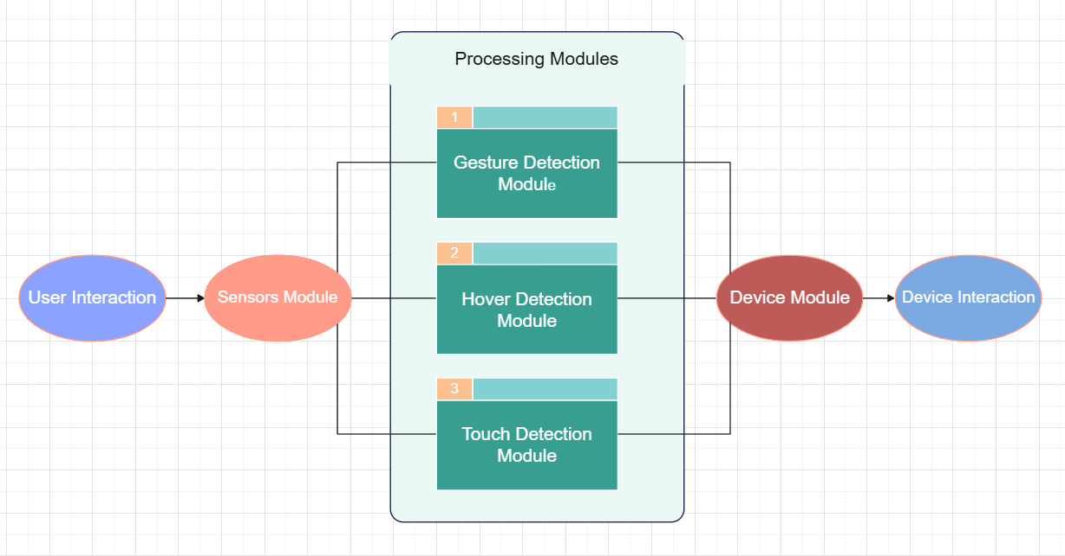
Fig 5.1 Software Architecture

5.2 Use Case Diagram

Adding Touch Interface to Existing Systems:
AirTouch aims to enhance existing computer or projector setups by adding touch functionality. Imagine a traditional classroom with a projector screen – AirTouch can instantly transform it into an interactive platform.

Public Spaces and Intuitive Navigation:
In public spaces like museums, airports, or information kiosks, AirTouch provides intuitive navigation. Visitors can explore maps, find directions, or access relevant information by simply touching the display. It eliminates the need for complex menus or buttons, ensuring a seamless experience for users of all ages.

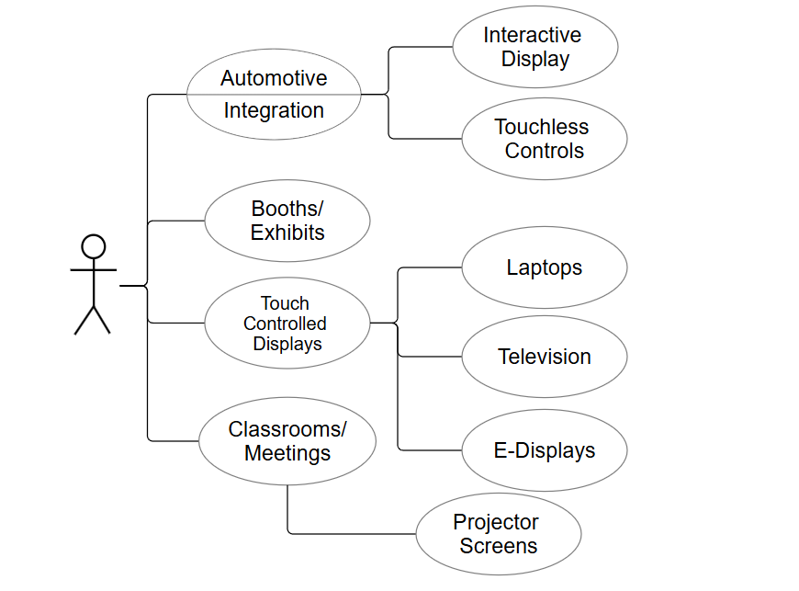
Fig 5.2 Use Case Diagram

5.3 Flow Diagram

Gesture Detection and Interaction:
  - The AirTouch system initiates when a user interacts with it. Whether it’s a tap, swipe, or hover, the system is primed to detect these gestures.
  - This initial step sets the stage for seamless interaction between the user and the connected device.

Tap and Hover Events:
  - The system branches into two paths: Tap Event and Hover Event.
  - For tap events, the Tap Module takes charge. It captures the precise coordinates where the tap occurred. Imagine tapping a virtual button on a touchscreen – the system records the exact spot.
  - The Tap Module then processes this information and sends a click event to the connected device. This translates into an action – opening an app, selecting an item, or confirming a choice. The user’s intent materializes seamlessly.

Complex Gestures and Machine Learning:
  - The Hover Event, on the other hand, involves the Hover Module. When a user hovers their finger over the interface, the system captures the finger coordinates.
  - The Hover Module dynamically moves the pointer to match these detected coordinates. Think of it as a virtual cursor following your finger movements.
  - Using advanced Machine Learning algorithms, it identifies complex gestures – swipes, circles, or custom patterns. These gestures are mapped to specific actions.

Real-Time Execution and Device Control:
  - All processed actions converge at the Device Module or Driver. This intermediary acts as a bridge between the software and the connected device.
The Device Module translates these abstract actions into concrete commands – a click, a scroll, or a zoom. It ensures real-time execution, allowing users to seamlessly control their devices.
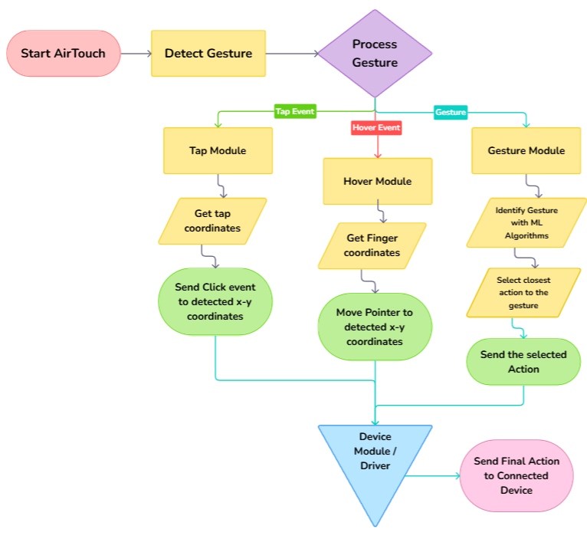
Fig 5.3 Flow Diagram for AirTouch

References

[1] author, title of the paper, title of the journal, volume no, issue no, issn number. Doi, year of publications.
Gagana, et al., "Innovation of touchless touchscreen technology in automotive user interface," Journal of Data Mining and Management, vol. 8, no. 2, ISSN 2456-7752, DOI: 10.5281/zenodo.7589012, 2023.

